Digital Security: Fortified Cyber Defence, Resilient Cyber Defence, and Trusted Autonomous Systems
Angela Mison

Introduction
A goal of this thesis is for digital security to take advantage of the differentiation between resilience, dependability, and cyber defence, each of which has developed into a specialism, and to recommend a proactive authentication and validation mechanism at the design stage which incorporates the principles of multi-factor authentication, without excessive processing overhead, that would reduce the number of cyber disruption attempts requiring actual defence or mitigation i.e. an increase in operational resilience.

While encryption would represent a solution, the processing required is too costly in terms of time for real time applications. This mathematical representation is underpinned by well-founded mathematics involving a number of identified applicable theories and exemplars. Going forward, what is suggested, a tractable defence in depth (National Security Agency, 2009), may provide a general approach which could be applied to protection of other areas of the critical national infrastructure.

Within the individual autonomous vehicle
It is recognised that some network architectures are more suitable to specific elements of the RTS than others, depending on purpose and priority of objectives. Within vehicles, CANBUS, and Vehicular ad-hoc Network (VANET), an equivalent to ethernet prevails and Actor Network Theory (ANT) is a useful mechanism for defining communicating sets, effectively virtual networks, and underlying network architecture, even in the face of CANBUS and VANET. Use of ANT results in the equivalent of a software defined topology, each segment of which can be thought of as a closed system.

Information warfare

Definition of information warfare and the setting of context
Today’s information, communication, and computer systems are under continuous and continuing attack. With the road transport system in mind, forming as it does part of the National Critical Infrastructure, the defences that should be applied, should reflect those of a response to information warfare. An attack may not be such to warrant a reflexive destructive response on the attacker by a defender, but the inevitability of an attacker's success indicates it is patently obvious that there should be a plan of graded responses.

Congressional Research Service (2020) Indicates that although lacking a formal definition, Information Warfare (IW) is generally considered as a strategy for the use and management of information to pursue a competitive advantage, including both offensive and defensive operations.

In Kopp (2003), it is reported that the Department of Defense (DoD) asserts a definition of Information Warfare, which is easily altered, as below, to remove it from the purely military and conflictual environment Information Warfare is any action to deny, exploit, corrupt or destroy… [an adversary's] … information and its functions, protecting … against those actions and exploiting our own … information functions’.

For information warfare, strategy encompasses planning. With respect to information warfare, information operations link objectives to which strategy is directed with tactics, techniques, and procedures. The classification of warfare used by the DoD serves a useful purpose in designating the types of attack which may be made on the RTS and provide a structure for dividing the complex problem of providing security for a potentially infinite problem space into sub-problem spaces which may be more manageable. It should be noted that these classes of attack may not occur in isolation and that an attack might be capable of classification within more than one class. Where that is the case, diversity indicates that a response should be defined in all cases where an attack is thought may occur as it will incorporate the differing mindsets of those addressing the relevant classes and specialisms, thereby extending the response space.

The DoD (Joint Chiefs of Staff, 2003) based on a report by Lebicki (1995) asserted that information warfare was not a singular activity, but could be divided into classes of operations:
- Command and Control warfare
- Intelligence -based warfare
- Electronic Warfare
- Psychological warfare
- Hacker warfare
- Economic warfare
- Cyberwarfare

The DoD (Joint Chiefs of Staff, 2014), updating their earlier report, provided fewer, broader classes of information warfare and corresponding information operations. It moved the defence to an information related capability defined as a tool, technique, or activity used to create operationally desirable conditions/objectives.

The reduced classification for which there was not a direct mapping to the earlier classification was:
- Cyberspace operations to include:
  - Computer network attack
  - Computer network exploitation
- Information operations to include:
  - Psychological operations
- Electronic warfare
- Operations security
- Deception

Cyberspace operations / Command and control warfare
An interesting philosophy of Command and Control warfare is that it is designed to 'cut off the head' of an organisation, thereby rendering it less able to respond.

Although directed at communications and information transfer, it raises the question of exactly who or what represents the head of the RTS? This question requires an answer, even if the command and control is determined to be fragmented, as in that case, there is a requirement for defining mechanisms for cooperation and collaboration, namely some form of disaster or emergency response plan, in the face of competition, propagating malware, and differing objectives. In responding to attacks on the Critical National Infrastructure, there must be unity between all the defending participants and potential targets for the response to be effective. An interconnected system is just that, interconnected and not isolated, thus with the potential to become part of the attack space. There may not be a possibility of isolating or microsegmenting subsystems.

The main weakness on the part of a defender is the visibility or reachability of targets and anonymity and visibility of attackers. While an intrusion detection system may identify the presence of an attacker or intruder, that identification may not have been effected before felonious activity or reconnaissance has taken place. In some respects, an intrusion detection system is a last resort defence against stealth, letting the defender know he has been attacked.

Command and Control Warfare is based on the intent to interfere or destroy a command and control capability. What Lebicki (ibid) represented is a subset of command and control technologies that exist now. Twenty-five years ago, Lebicki (ibid) stated command and control related to interference with or destruction of:
- Microwave relay towers
- Telephone exchanges
- Switching rooms
- Fibre optic nodes bridges for coaxial communications cables

From the above, it can be ascertained that the intent of command and control warfare is designed to interfere with or prevent communication or transmission of information, thereby disadvantaging the subject of an attack through incomplete knowledge. With respect to the RTS, this can be interpreted as attacks on the infrastructure, communications headquarters, the communications between manufacturer and vehicles and the communication between vehicles.

Intelligence-based warfare
Intelligence- based warfare is founded in and around threat intelligence. It is based on the assessment of the motivation, capability, and objective of any attacker and of defined weaknesses within systems.

An awareness of the meta-environment in which systems operate is necessary. The identification of potential adversaries and their associated social and cultural norms together with a forward view of the malicious purposes for which new technologies could be used must be a consideration in effective planning of the information response capability. Intelligence-based warfare examines, analyses, and exploits the soft elements of information warfare.

When used defensively, it is likely to take on an adversarial deception mode to decoy, confuse or misinform a potential attacker. Whether this misinformation, confusion, or imposition of incomplete knowledge is more than an information collection exercise is dependent on the policies in place with respect to a defensive response. It is but a short step from defence to attack and it will involve a reference to authority.

Used offensively, the use of intelligence-based operations seeks to pre-empt attacks by means of advanced potential threat identification, whatever form that may take. The maxim 'defenders must be lucky all the time, successful attackers lucky only once' holds true.

It should be recalled that any interference with potential attackers' systems may bear cross- jurisdictional consequences regarding legislation or may be subject to UN restrictions in respect of justified retaliation. Pre-emptive forays in anticipation of a future attack presuppose knowledge of commitment to action on the part of the attacker, not always a simple, provable element which is more often assessed by the balance of the probability of action versus the effect of the action and estimated time for recovery.

Consideration of the RTS leads to the conclusion that although an attack on the infrastructure may be limited nationally, attacks on vehicles may propagate globally. It is only necessary to consider the differing infection rates of Covid-19 under different regimes and the resulting cross infection rates outside the borders of those regimes, to put this into the current and relevant context of an interconnected world.

Electronic warfare
The DoD describes electronic warfare as an action involving the direction or control of electromagnetic spectrum to deceive or attack (Wilson, 2007).

Overloading or disrupting electrical circuits using directed energy weapons which amplify or disrupt electromagnetic fields is possible. Equipment is available for achieving these effects, use of which can result in overheating, permanent damage to circuits, jamming or disrupting processing in computer systems. Within the DoD, this operation is the responsibility of the Electronic Warfare Division of the Army Asymmetric Warfare Office. In addition, regarding the RTS, such tools could affect GPS systems, radios, aid in the takeover of systems and alter the behaviour of connected and automated vehicles.

As an example, interference is possible in swarm behaviour of vehicles, to the detriment of the occupants or the operation of the vehicle and infrastructure. Vehicles may be persuaded that there is no traffic present, that there is stationary traffic, that the proximity of image manipulated vehicles requires immediate defensive action or all shades in between. Inter vehicle communication can be considered akin to teleconferencing with the vehicles altering their behaviour or terminating progress of the vehicles in the light of incoming signals.

Psychological Warfare
Using the original DoD definition of psychological warfare (Joint Chiefs of Staff, 2003), this is designed to affect the perception of those under attack. An anonymous quotation describes the objective adequately: Capture their minds and their hearts and souls will follow.

The objective is to achieve a psychological affect or change in perception in the minds of the target audience. The anonymity of the internet presents great opportunities for plausible deniability. Efforts to alter perception take place in the information environment which consists of people, organisations and systems that act on, use, or disseminate information at the cyberphysical boundary which comprises:
- The physical dimension
  - Where information and the real world coincide

- The information dimension
  - Related to data, its processing, storage, dissemination, display and protection. It is concerned with both content and flow of data and the transformation of that data into information

- The cognitive dimension
  - Related to the decision making that derives from perception. It is not the sole remit of the usual information warfare protagonists, and involvement often emanates from the institutions more usually concerned with soft power

Evidence of psychological warfare is evident in American politics where the elements of use are easily identified and exhibited in the use of social media and bots, as exemplified by the Cambridge Analytica use of PsyOps.
- Propaganda – intended to influence
- Disinformation – intentionally false
- Misinformation – unintentionally false

An example of psychological warfare usage related to the RTS could be dissemination of information intended to influence the populace that autonomous vehicles are inherently unsafe, thus unacceptable. An education program is currently in place to make autonomous vehicles acceptable to the general public and whether or not this can be categorised under psychological warfare, it is certainly an influencing programme from the Government and manufacturers to ensure that autonomous vehicles are perceived as the norm at some point. Interestingly, the category in which this education is placed is debatable and dependent on the existing perception of the recipient.

There has been an obvious erosion of public trust in authority related to the abuses of power publicised, whether by propaganda or disinformation is irrelevant. Activists in the surveillance, privacy arena are making headway.

A most recent example may be the reaction to the deployment of facial recognition tools used in populous areas, or the reluctance of some to have a track and trace app related to Covid-19 on their mobile phones. Even without the track and trace app, organisations have monitored and modelled the potential distribution of the virus through mobile phone GPS activation. Whilst there may be little active opposition in the face of a global pandemic for such an app, the erosion of trust relates to its removal, destruction of data and guaranteed cessation of use for any other purpose.

Hacker warfare
It is difficult to describe a standard hacker; they vary from an individual, through a criminal organisation, up to and including nation state actors. It may be difficult to distinguish between hackers and cyber terrorists in the first instance.

With the advent of Crime as a Service, a hacker no longer needs to be technically sophisticated. Tools that are designed to gain access to systems and effect felonious acts are available to purchase, readymade, from the dark net. It is possible to commission tools or hire subcontractors to commit the actual transgression adding yet more distance from, and anonymity to the act. For those acting in Crime as a Service capacity, it is a simple business proposition. The determination is whether a product is sold outright, leased or licensed.

In this context, a hacker will be defined as an 'individual' with an objective or purpose for the infiltration of a system. It is the responsibility for the objective that is the defining characteristic, irrespective of whether they themselves have developed the tool used, purchased it or commissioned a sub-contractor to effect the act.

The motivation for hacking is a likely determinant of the type of hack. In many cases the objective of the hack cannot be determined initially and is an example of incomplete information. In some cases it may be possible to passively track the hacker's actions, whilst in others, there may be some 'cat and mouse' element. Objectives may not be malicious, but are unlikely to be beneficial in the absence of bounties. Until the motivation is determined and type identified, it may not be possible to complete a response, strategic or otherwise.

In the RTS, motivations for hacking may derive from:
- Hacking for fun
- Hacking for reputation
- Hacking because they can
- Hacking as reconnaissance of the system or of defences
- Hacking to attack a system
- Hacking to paralyse a system
- Hacking to satisfy some consequential need e.g. gore porn, slowing through traffic in a town with no by-pass
- Hacking for some unknown objective other than a detected consequential manifestation

Economic warfare
Militarily this is considered as channelling or blocking information pursuant to economic dominance, but in reality, when considering Chinese insistence on local partners for international enterprises and the concomitant reverse engineering to gain unauthorised access to intellectual property, economic warfare can be seen in a broader perspective.

The straightforward hacking of systems to gain access to intellectual property and research and development could be viewed under Hacking warfare, but its objectives may differ and may be commercially or nation state activated.

Not all blocking activity is directed to economic warfare. Authoritarian, paternalistic or regimes under threat may seek to block the flow of information for stated or unstated reasons. In order to avoid some aspects of persecution or identified reactionary individuals, there is some capacity to mask IP addresses through VPNs and TOR, although both mechanisms have their weaknesses and are not as secure as advertised and this activity can also be classified under the heading of cyberwarfare.

Cyberwarfare/Operations in the information environment
Information Warfare is defined as a subset of operations in the information environment in order to dominate the information environment at a specific place and time (Department of Defense, 2018). Its objective is below armed conflict, but this may be a finely tuned judgement based on assumptions of the adversary and his responses. Militarily, this assessment is played out in games, in advance of actual conflict. Judgement is not something inherent to the information operation environment and represents the human input to cyberwarfare.

The DoD (Joint Chiefs of Staff, 2018) defines cyberspace thus: the global domain within the information environment consisting of the interdependent network of information technology infrastructures and resident data, including the Internet, telecommunications networks, computer systems, and embedded processors and controllers.

The elements described are the creation of individuals and are subject to policies and procedures in an environment where adversaries are in conflict, attack and/or response. Unless the consideration is that cyberspace is non-evolutionary and carried out between autonomous systems, this is an inadequate definition attached to the concept of cyberwarfare, and it is hoped that any war effected is not so remote from the resulting moral consequences and hazards which lead to actions such as the bombings of Hiroshima and Dresden, or the apocalyptic destruction of infrastructure on which society has become dependent for its existence.

There is some recognition of these facts as recorded in Operations in the Information Environment (Department of Defense, 2018) which asserted that the information environment comprises and aggregates numerous social, cultural, cognitive, technical, and physical attributes that act upon and affect knowledge, understanding, beliefs, world views, and, ultimately, actions of an individual, group, system, community, or organization. The IE also includes technical systems and their use of data. The IE directly affects and transcends all operating environments.

The newly defined policies in (Department of Defense, 2018) would appear to define
cyberwarfare as actions taken to generate, preserve and apply informational power against a
relevant actor in order to increase or protect competitive advantage or combat power potential within all domains of the operating environment.

Defence in depth
Defence in depth, driven by the defence industry, is the multi-layering of defences to provide increased protection to a system under attack. It serves several purposes:
- Raising the cost of an attack
- Providing multiple barriers
- Providing diversity in defence, the deeper an attacker goes, the more difficult it should get
- Providing elements of information assurance
- Preventing direct attacks
- Preventing easy reconnaissance
- Expanding the time available to detect an intruder
- Expanding the time available to respond to an attack
- Reducing the impact of an attack
- Enabling the possibility of deception techniques to misinform the adversary

The identified elements which are advantageous to defenders are related to economics and timeliness. The difficulty in a constrained system relates to complexity, processing power and response time e.g. is defence in depth possible in a vehicle?

By modelling various attacks in Game theory, extended form games, stochastic games, supergames or hypergames, it is possible to effect a paper exercise which should provide a mechanism for prioritisation of defence techniques and their location. The military have used hypergames in their exercises as they model incomplete knowledge under conflict and permit a time sequenced element in addition to decision theory based weightings on actions. The complexity of the parameters of the game are highlighted in the elements involved in the information environment in addition to behavioural theory needed to define rationality/irrationality of an adversary.

The aim of any security system is to constrain an adversary to the periphery. In the RTS, the periphery is not well defined. Attacks can be applied nationally, within a system or subsystem, operationally or tactically. Defence in depth should provide a unique defence at each layer, thus require different attack approaches at each layer. With respect to an autonomous vehicle, the example of the Boeing 777 may be used. The Boeing 777 is the result of paperless design and operates as a fly-by-wire aircraft. It is a network of networks, not an isolated network and as such, each interconnection is a point of vulnerability, whether that is at the system boundary or the individual subsystems boundaries.

Fortified cyber defence
Fortified cyber defence incorporates both network cyber defence at endpoints, and resilient cyber defence at the API. The objective of the use of fortified cyber defence, network cyber defence and resilient cyber defence together, is the creation of a closed, trusted autonomous system (TAS), which is defined as [a] socially beneficial autonomous system that [is] both trustworthy in principle and trusted in practice by individuals, society and government (UKRI Trusted Autonomous Systems Hub, 2023).

Fortified Cyber defence recognises that even without external intervention, no ‘correct’ system has ever been deployed that did not reveal errors during operation. The thrust of the thesis is to show that with analysis, even legacy systems can be transformed, retrospectively to an approximation of a TAS. It provides some comfort in the knowledge that there are limited time intervals available for a malefactor to access any part of the system, as at multiple levels, the tokenisation is dynamic, includes time as a parameter, and can be subject to different algorithmic authentication, verification and validation, which satisfies a goal of defence in depth.

Domain driven design
The identification of elements and networks in the preceding chapters, and the concept of fortified defence parallel the goals of domain driven design (DDD) (Evans, 2004) which has similarities with object-oriented design. DDD leads to the analysis of independent problems /domains as bounded or constrained as discussed in relation to containers in .NET Microservices: Architectures for Containerised .NET Applications (de la Torre, et al., 2023). The identification of communicating sets, their purposes, and ODD is intended to minimise any information flows or external communication outside the ODD or network.

Fortified cyber defence, as defined previously, would appear to reference historical and current methods of achieving cyber security, but it has not taken into account the technological advances that may be subverted for use. Using or appropriating concepts from these advances and other areas where security is of paramount importance may enhance the security of the RTS and may contribute to the goal of asymmetric advantage in cyber security.

Dependability and resilience arise from internal development of the domains. Examination of network architectures can provide a further layer to the goal of asymmetric advantage in cyber security. Decision making can be distinguished from authority in network architectures.

In terms of cyber security and the concepts of fortified defence, isolation or segmentation of a decentralised node, can be viewed as a crude response, but it has the least impact on operation of the whole. Independence is achieved through built-in resilience and dependability during development, the rest of the network can continue without the segmented component or isolated network sector as defined by use cases or scenarios. In this thesis, isolation will refer to the network and microsegmentation to the component systems security. The whole is redolent of Continuity in the face of system failure.

Trusted autonomous system
The achievement of a trusted autonomous system (TAS) can be evaluated from the different perspectives related to individual, society and government, as indicated by the UKRI Trusted Autonomous System Hub (2023). In this instance, ‘society’ can be defined by system characteristics:
- Predictability – a general societal concern related to system external behaviour
- Dependability – a consumer concern related to expectation of vehicle behaviour
- Resilience – an internal concern related to continuity of operation
- Security – an RTS element concern related to access by external/unauthorised entities

Network cyber defence
Network cyber defence is concerned with ensuring that potentially communicating parties are within the context and that they can communicate as defined in the communicating sets. It requires the establishment of a finite set of Whitelists to be tested against, as it is impossible to define an infinite blacklist. If the IP addresses do not match with a member in the communicating set, microsegmentation or isolation takes place and the attempt is flagged for investigation. There is no second chance, but investigation may reveal that the communicating sets require updating. This is outside the scope of the thesis.

Adapting to new technologies
This thesis provides the basis of fortified cyber defence, a reworking of the principles of defence in depth (National Security Agency, 2009) which gives the flexibility of adding or changing authentication and verification points and algorithms at will or autonomously, without the need to change operational code. Furthermore, it is a move away from third party suppliers to the owners of systems who identify and dictate what is a priority arising from risk management.

The starting point for the solution, and more importantly the implementation, is a process analysis of the interactions of individual autonomous vehicle aided by use of Actor Network Theory Invalid source specified., Invalid source specified.. Fortified cyber defence being independent of the operational system, can take advantage of technological advances. It protects legacy investment as being independent of operating code for example, utilising the principles espoused in Arqit (2024) for the quantum-safe dynamic generation of keys and their use as identification tokens, thereby providing asymmetric advantage.

Resilient cyber defence
The purpose of resilient cyber defence and its use is to avoid catastrophic failure and provide a solution to continuity based on FAR during scenario development. No information flows should be outside those permitted by the ODD.

An example of resilient cyber defence is given in Figure 23. It is concerned with information flows and data. At the API, it validates parameters as input to internal vehicle and component functions by reference to the ODD and the validity of the connection between the source and destination. There are two elements to the parameter list, an operational parameter list destined for the component or function, identifiable in the ODD, and an authentication and validation parameter list which is part of a security algorithm sitting above the operational component or function.

A Boolean TRUE arises from a known and permitted communicating component mapping existing in the communicating sets, that the requirements set by the invariant are met, and that the operational parameter list is in the ODD. It is recognised that time is a crucial element in resilient cyber security execution, thus risk assessment may limit authentication and validation to priority elements.

Compartmentalisation
Although there are marked similarities between network cyber defence and resilient defence, the distinction is between permitted access of network cyber defence, and permitted access together with permitted data flow of resilient defence. From this distinction, it can be seen that viewed as a compartmentalised systems such as would result from Security-oriented analysis of application Programs (SOAAP) (Gudka, et al., 2015), all the parts of a system can be viewed as a microcosm of the RTS in that they have a purpose, structure, ODD, and behavioural element, thus can be the subject for an axiom system in their own right.

The specialist digital security knowledge required is reduced, simplified and within the grasp of developers who have to distinguish the external boundaries of the system they are working on and apply the principles of fortified cyber defence. It is left to cyber security experts to apply their skill sets, knowledge of historical attacks and threat analysis at the external boundaries of any constituent system. This approach requires knowledge and understanding of the constraints of sufficient and necessary communication and reference to the relevant communicating set and a recognition that in any compartmentalised system, to the developer, the boundaries of the compartment separate the external from the internal.
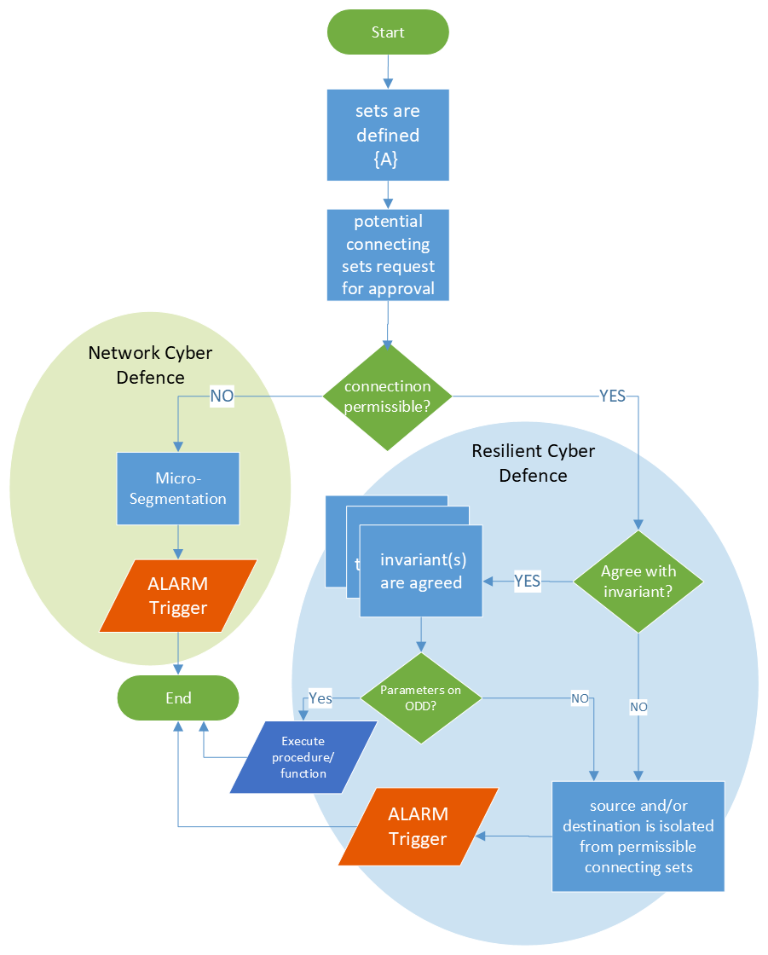

Figure 23: Fortified Cyber Defence

Network segmentation and isolation
The network segmentation concept is utilised further in communications. Borrowing from the historical ideas of closed user groups and Russian proposals for internet segmentation (Kukkola, 2020), which indicate that significant structural changes provide asymmetric cyber security advantage, this approach can be applied to automated vehicles.

Stadnik (2019) provides a synopsis of perceived advantages from the Russian perspective. Georgia Tech Internet Governance Project (2019) provides a critique of the enabling Russian Federal Law 90-FZ, and notes the reluctance of both Gazprom and RZD who stated the proposals may act to violate their isolation and challenge their security (Commercial Gazette, 2019). In the event that a corrupt signal is received within the RTS or any of its constituent networks, that segment of the RTS network can be ring-fenced, thus preventing propagation of corruption.

How would it work in a vehicle?
It is recognised that such an approach in an autonomous vehicle presents as a closed system which if adopted, may require a national policy and mandate that are outwith the authority of the manufacturers. A closed system is the antithesis of open internet and the potential for utilisation of Edge computing. It is possible during the requirements specification to identify permissible communications of a limited set of actors defined by their contributions to the vehicle, its ODD and DDT, scenarios, or RTS i.e., a whitelist. It is not possible to define all impermissible communications, a potentially infinite set.

However, should a communication not meet the invariant for a permissible communication, as a default, it is considered impermissible or corrupted and discarded in line with the rules derived from the Russian proposals for internet segmentation. No communication from the failed source, destination or both is permitted. This approach will be represented as fortified network and resilient defence systems as described in Dewar (2014). The hypothetical solution seeks to address the concerns raised by Brown (2013) using several layers of interactions, geographic and authentication approaches that act as progressive filtering mechanisms, attempting to ensure the relevance and appropriateness of the parameter lists and instructions arriving at componentry without the overhead attributable to RSA encryption.

This thesis recognises the internal and external context of and within the RTS, attributing the verbs microsegment to refer to creation of internal inaccessibility, and isolation to refer to creation of external inaccessibility. However, the distinction between internal and external becomes moot to a developer working on a compartmentalised part of the system. To the developer, external may mean external to the component on which they are working. Semantics will matter. Isolation may also be caused by error, and failure to match a a whitelist while microsegmentation includes not matching parameter list within the ODD. Micro segmentation is not solely due to non-matching within a communicating set.

With reference to the domino race analogy and the removal of a domino to prevent propagation of the race, APIs act as potential break points in the flow of corruption, minimising the opportunity for transfer into the functional units. The concept of internet isolation results from Actor Network Theory (Law, 1996) to define a geography of authorised virtual networks enabling an API security approach based on an additional parameter list of associated timing ranges based on energy, speed, frequency and latency, combined with signature authentication based on the virtual geography. Such cyber security will be defined without consideration of a vehicle as a monetisation platform, but does take account of the goals of the RTS, and the vehicle contribution to those goals.

A vehicle has many microcontrollers which are often sourced from third-party suppliers, and which may interact with the system and which like the Ripple 20 vulnerability may be the cause of potential failure. Retrofitting of security to a third-party supplied componentry will not be considered as it is outside the scope of this thesis, but the hierarchical approach remains applicable.

It should be noted that the supply chain is integral to the manufacturer and not the RTS, and that the recommendations of the Law Commissions (Law Commision of England and Wales; Law Commission of Scotland, 2022) dictate immutability of vehicle systems. The above will apply to the ODD of vehicles, and utilising Field Anomaly Relaxation (Vervoort, et al., 2015) to develop scenarios, will enable the manufacturers' choice within their digital twins of resilient behaviour to be encoded and integrated in a manner where judgements can be recorded for audit or forensic purposes.

Where either the source or the destination, or both are invalid at the API, the incorrect element is isolated. Vehicle operations can continue via onboard sensors detecting and avoiding an obstacle whether mobile or not, but direct communication between parties identified as incorrect will be no longer permitted. It is possible for the affected/infected vehicle to go into resilient operation depending on the source or destination of the potential communication and either mandated behaviour or manufacturer's predetermined reaction to such a scenario. Within the phalanx or group, the vehicle may be identified as a mobile (or not), non-communicating object to be avoided.

Fortified defence
Fortified defence addresses authorisation and authentication – is party A permitted to communicate with party B? It can be used at the network endpoint, and/or the API.

For the network endpoints, the check is against predefined whitelists within communication sets for that endpoint and can either microsegment incorrectly identified sources and/or destinations, or otherwise respond as programmed. Sources or destinations which have been thus segmented cannot communicate with the RTS, neither can the element(s) of the RTS connect with cause of microsegmentation or isolation communicate with them. If in a permitted communication set, they are temporarily removed from possible communication pending investigation.

For this to work, the process, defined in greater detail in Chapter 7 Scaling Safety: The Operating Vehicle World: Specifications and Functions, states it is necessary to discuss the ‘key’ to communication:

- Every vehicle has an identity and belongs to a group and phalanx
- The individual vehicle has a constant identity throughout its journey
- This key is defined at ignition and is based on an endorsement key, an attributed default identification number which comes from an authorised body, confirmed by the monitoring body, and the time of ignition
- A request using calculated vehicle identification, default group and phalanx identities is made to the central authorising authority
- The central authorising authority identifies the vehicle is authorised to operate in the jurisdiction
- The central authorising authority passes the authorisation to operate in the jurisdiction to the operating authority
- The operating authority transmits the approval to operate and any other relevant data to the vehicle, the relevant monitoring body and the traffic management system
- The vehicle transmits its values to the monitoring body for cross checking with the operating authority values

Figure 24 demonstrates how these concepts can be applied.
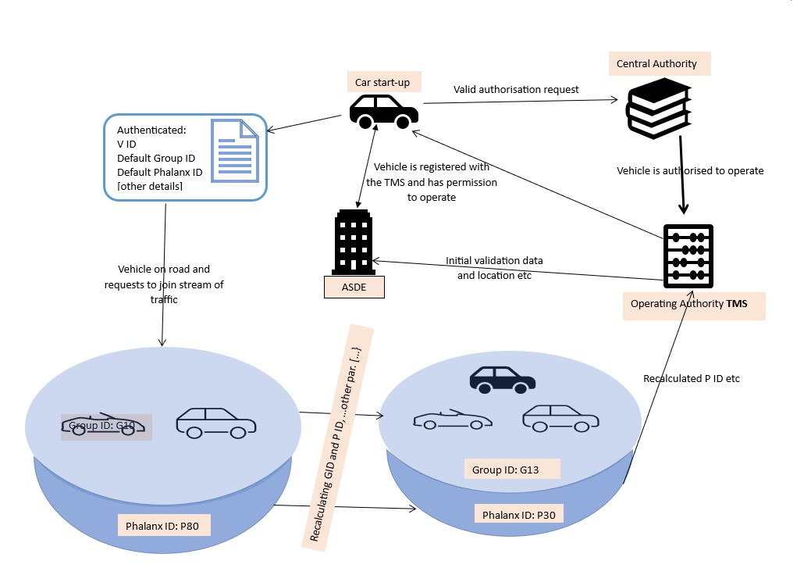
Figure 24: Showing ignition process and joining first stream of traffic

- Group and phalanx identities change during the journey as the individual vehicle joins and leaves various traffic streams during its journey
- The identity of groups and phalanxes contain a timestamp together with a hash of their constituents’ identities which renders them unique and of short existence
- The phalanx is the intermediary for communication with the traffic management system

Source and destination of the communication will be required in the parameter list to identify the location of emanation of a corrupted parameter string. Upon recognition of the corrupted parameter string or key, the isolate function is initiated together with a NOTIFY function that will include a time stamp for the monitoring body. In this manner, the dependability and reliability of systems should manifest, as a frequent switch to a limp home or resilient mode, is likely to be unacceptable to autonomous vehicle users and affect the dependability value of the vehicle to the disadvantage of the manufacturer.

It is expected that the security of permitted parameter list matching from within the ODD, source, destination, and a generated key based on the operational knowledge of the system will reduce the actual number of infiltrations and corruption attempts/events within the RTS. Whilst not truly proactive, it functions in a highly negative manner in that for whatever reason communication or processing is not permitted, it is automatically rejected. The combinations of validation and authentication should defeat all but the most determined of hackers or novel malware which is unlikely to have the complete knowledge of system operation characteristics, formulation of a timestamped key, or structure of the underlying algorithms used for authentication, verification and validation.

The key itself is unique, may be variable across models and can be based on pattern of life calculations determined by the manufacturer. Update of an immutable autonomous vehicle system would provide the opportunity to change the key, time limiting its exposure to malefactors. This process should be automatic and based on the updated system. As with the example of a hashing algorithm, updating anything in the system may change that system's operational characteristics.

Simple permitted parameter list matching is not novel, neither is including a source and destination of the parameter list. The novel aspect is the use of a variety of mathematical theories to define a complex key not only based on operational characteristics, but which may include random elements and which itself can be encrypted, depending on the priority and degree of security required.

It is accepted that, initially, key matching authentication and parameter list validation may reduce performance which will be reflected in reduced capability of the automated vehicle, but the decision is between policy makers and manufacturers if there is precedence between safety and security.

Cyber security functions
For optimisation purposes, any subset that exists in A as defined in Chapter 5 Context and Structure: Communicating Sets, may be represented by CS in the mathematics. In reality each source and destination will be assigned to a specific communicating set; the disjunction of all sets which are members of A will be ∅ the empty set. That is a construction rule which has not been addressed in Chapter 5 Context and Structure: Communicating Sets as neither ANT nor process analysis is pertinent to the primary analysis.

Cyber security functions type definitions
CS : {[src → dest]}
A : {CS}
src : [Token]
dest : [Token]

Can_communicate
This function determines whether a source and destination are permitted to communicate i.e., the values are within a communicating set as defined in Chapter 5 Context and Structure: Communicating Sets.

Can_communicate function definition
Can_communicate : f({[x → y]}, <a, b>) → Boolean

Can_communicate function invariant
((CS ⊆ A) ∧ (∀x : Source, ∀y : Destination) . ∃!([x → y] | [x → y] ∊ CS)

Can_communicate function
Can_communicate (CS, <src, dest>) = ([src → dest] ∊ CS)

Isolate
These functions segment or compartmentalise a section of the system which is subject to a FALSE value being returned by the Can_communicate function. They can be applied to the source and/or destination address.

In addition, the undefined command NOTIFY has been included as it provides the starting point information for investigation and reinstatement of the segmented or isolated portion of the system, and highlights that an error or attack has taken place. It is assumed that the Notify function triggers an alarm within the monitoring body, but this is an implementation issue outside the scope of this thesis. It is in the nature of evolving systems that there may be a delay in the addition to the communicating sets which would trigger these functions, not all of which are the result of corruption.

Isolate_source

Isolate_source function definition
Isolate_source : f({[x → y]}, <a, b>) → {[x → y]}’

Isolate_source invariant
Can_communcate (CS, <a, b>) = FALSE

Isolate_source function
Isolate_source (CS, <src, dest>) = A’ |
((∀CS ∊ A’, ∀x: Source, ∀y : Destination) . (¬∃(( [src → y] ∧ src = x) | [x → y] ∊ CS’) ∧ CS’\CS = {[src → dest]})
∧ NOTIFY

Isolate_destination

Isolate_destination function definition
Isolate_destination : f({[x → y]}, <a, b>) → }{[x → y]}'}’

Isolate_destination function invariant
Can_communcate (CS, <a, b>) = FALSE

Isolate_destination function
Isolate_destination (CS, <src, dest>) = A’ |
((∀CS ∊ A’, ∀x: Source, ∀y : Destination) . (¬∃(( [x → dest] ∧ dest = y) | [x → y] ∊ CS’) ∧ CS’\CS = {[src → dest]})
∧ NOTIFY

Add permissible communication
This requires authentication on the part of the responsible and accountable authority, but the invariant and function definitions are simple, but do require an acceptance or rejection by the responsible and accountable authority.

Add_permissible_communication function definition
Add_permissible_communication : f({[x → y]}, <a, b>) → {[x→ y]}’

Add permissible communication function invariant
((∀CS ⊆ A) ∧ (∀x: Source, ∀y : Destination)) . (¬∃( [x → y] ∊ CS))

Add_permissible_communication function
Add_permissible_communication (CS, src, dest) = CS’ |
(([src → dest] ∊ CS’) ∧ (CS’ \ CS = [src → dest]) ∧ (|CS’| = |CS| + 1))
∧ CS ⊄ A ∧ CS’ ⊆ A

Resilient cyber defence – API security
When at the API, a check of the validity of the parameter lists represents a permitted process communication (or a process whitelist). Incorrectly identified attempts at communicating through the API are subject to microsegmentation, similar to the isolation function.

Vehicle identities are generated elsewhere than the vehicle during initialisation, and are time limited, lasting only until engine shut off. Internally to the individual autonomous vehicle, there is no expectation of the need for external communication. All communication relating to operating functions of the vehicle are from its own communicating set of C2C. It is only within the concept of the group that there is V2V communication during swarm behaviour. Externally, during swarm behaviour, it would be possible to check an incoming source against the addresses contained in the distributed group or phalanx knowledge base.

Possible implementation
The example given here is associated with the individual automated vehicle. Resilient cyber defence at the API, in this context is a two-phase operation. Any process or component within the DDT could have two distinct parts to its parameter list as submitted to the security gateway at the API. The security element of the parameter list is associated with source of inputs and destination of outputs.

As indicated, the system is not one mass of interconnections, but structure and compartmentalisation has been applied and similarly, to fortified defence, checking the source and destination of components permitted to communicate with each other, the communicating set C2C, is a simple test involving authentication keys, the communicating sets held wherever is determined by policy.

Having passed the first test, validation addresses ODD permitted parameter lists, finding the set of parameters within the ODD that match the relevant operational parameter list. Only when these two tests have been passed, is the operational parameter list passed through to the operating function. Extreme gatekeeping, but in terms of defence in depth, workable. Performance may be degraded, but technological advancement will make such a solution faster.

It is possible to use the Can_communicate, Isolate_source, Isolate_destination, and Is_permissible functions on the source and destination addresses carried by vehicles, using them, as extracted from an extended, permissible parameter list, in the same way as for endpoint protection. An alternative would be to carry these values, identity and source addresses in an operating vehicle knowledge base which could be matched for high priority security. Individual vehicle knowledge would have an element source address, so any vehicle receiving an extended parameter list would only need to match the source. This solution has not been represented in this thesis, as the operating vehicle knowledge base is undefined and how this will be achieved is an implementation issue, not a primary analysis issue.

In total, resilient cyber defence in this context deals with permitted parameter lists, the operational design domain, permitted communication sets, and authentication keys from permitted communicating parties defined within {C2C}. The information necessary for resilient cyber defence derives from scenario development as the foundation of the ODD.

Resilient defence functions
For exemplary purposes, optimisation, and readability purposes the following assumptions have been made:
- the relevant subset that exists in A may be substituted for A in the representations
- the authentication key is given as the vehicle identifier
- the second parameter list is for the operational/functional code
- the source and destination will be predefined in some communicating set in A.

Resilient defence type definitions
Types not defined here have been defined previously
Operation_Design_Domain : {<[src → dest], <param>>}
Permitted_Parameter :: {<[src → dest], k, <param>> }
PPL : Permitted_Parameter
Parameter :: [Token]
P, param : Parameter
k : Key :: [token]
ODD : Operation_Design_Domain

Resilient defence function Can_communicate

Resilient_defence function Can_communicate definition
Can_communicate (CS, <src, dest>) → Boolean

Resilient_ defence function Can_communicate invariant
((Can_communicate (CS, <src, dest>) = TRUE)
ꓥ (∀x, ∀y | ([x → y] ∊ CS) . (∃[src → dest] ∊ CS))

Resilient defence function Can_process

Can_process function Can_process definition
Can_process (src, dest, CS, PPL, ODD, k, <param>>) Boolean

Can_process function Can_process invariant
((Can_communicate (CS, <src, dest>) = TRUE)
ꓥ (k = v.id)
ꓥ ((∀x, ∀y) | ([x → y]) . (∃[src → dest] ∊ CS))
ꓥ ((<[src → dest], k, <param>>) ∊ PPL)
ꓥ ((<[src → dest], <param>>) ∊ ODD)) = TRUE)

Concerns

Threats
As the group and phalanx comprise a set of individual operating autonomous vehicles, they represent the most dynamic part of the RTSs and may be most likely to form a breach of zero-trust, enabling corruption to enter into the more static parts of the system via the effective supply chain, speed of maintenance, dependence on third parties during manufacture (Mison, et al., 2022b), and passage of data to the infrastructure thence to the traffic management system.

Operational vehicles
The group and phalanx are artificially created artefacts which serve fundamentally different purposes. The group is associated with safety, enabled through swarm behaviour, while the phalanx is that collection of vehicles seen from a Traffic Management System perspective which is concerned with achieving free flowing traffic.

The representation for groups and phalanx operation is given in Chapter 7 Scaling Safety: The Operating Vehicle World: Specifications and Functions, and the individual vehicle in Chapter 6 Scaling and Safety: Autonomous Vehicles World: Specifications and Functions. There could be an alternative choice of placing a phalanx identification in the vehicle as opposed to in the infrastructure. This recognises that a vehicle may initialise in a communication black spot, but that is beyond primary analysis and a scenario, thus outside the scope of the thesis. It is a policy decision to be implemented by the relevant elements of the RTS, but is counter to the Law Commission’s Recommendations (2022) and Automated Vehicles Act (His Majesty's Government, 2024b) which requires connection to a monitoring body before operation can commence.

Updating knowledge bases: Static v dynamic knowledge bases
The communicating set A is part of Universal knowledge. Where the communicating set CS is either Phalanx to Infrastructure (P2I) or Infrastructure to Phalanx (I2P), these are communicating sets in respect of the operating vehicle world and the requirements for dynamic knowledge base of communicating sets in that world will require updating on a frequent basis as the phalanx is a dynamic artefact required for hypothesised traffic management purposes, while the infrastructure is permanent.

The dynamic communicating sets thus created cannot be a part of static knowledge. The unique vehicle identifier generated on ignition and lasting until engine stop can be passed to a relevant communicating set management system to optimise the Can_communicate, Add_permissible_communication, or dynamic communicating set construction. An assumption is that the address of a vehicle thus identified is valid unless contraindicated through the isolate and NOTIFY elements.

Where vehicles are added to the population, the requisite sets will require updating.

Updating knowledge bases: Navigation
It is not fully defined how the N2V sets will be updated with increasing population which represents a current vulnerability. A possible solution is that manufacturers registering vehicles with the RTS will also register vehicles with the navigational system the vehicle will use, providing an automatic but functionally limited intercommunication. Where such real time communication is not possible, vehicles will defer to on-board route maps.

A caveat with regard to the possibility of communication is that where communication is not possible with the navigation functions, it is possible that communication is also unavailable in terms of the monitoring body, in which case the vehicle will stop. The Automated Vehicles Act (His Majesty's Government, 2024b) does not permit operation of autonomous vehicles without connection and effective monitoring.

Some interoperability between the Navigation Systems and the Traffic Management Systems is assumed to reflect the changes in Infrastructure that will constrain possible routes. These are outside the scope of this thesis.

Conclusion
The result of the security check, Can_process (src, dest, A, PPL, ODD, k, <param>>) is the passage of the operational parameter, <param> to whichever function or algorithm is being protected by the security function Can_communicate. As nothing is or can be defined with respect to black boxes, this merely demonstrates that security can be applied and can be independent of operational code.

The above representations should permit the retroactive application of security without alteration of operational code, thus permitting the system to move closer to the goal of a trusted autonomous system and protecting investment in legacy systems.

